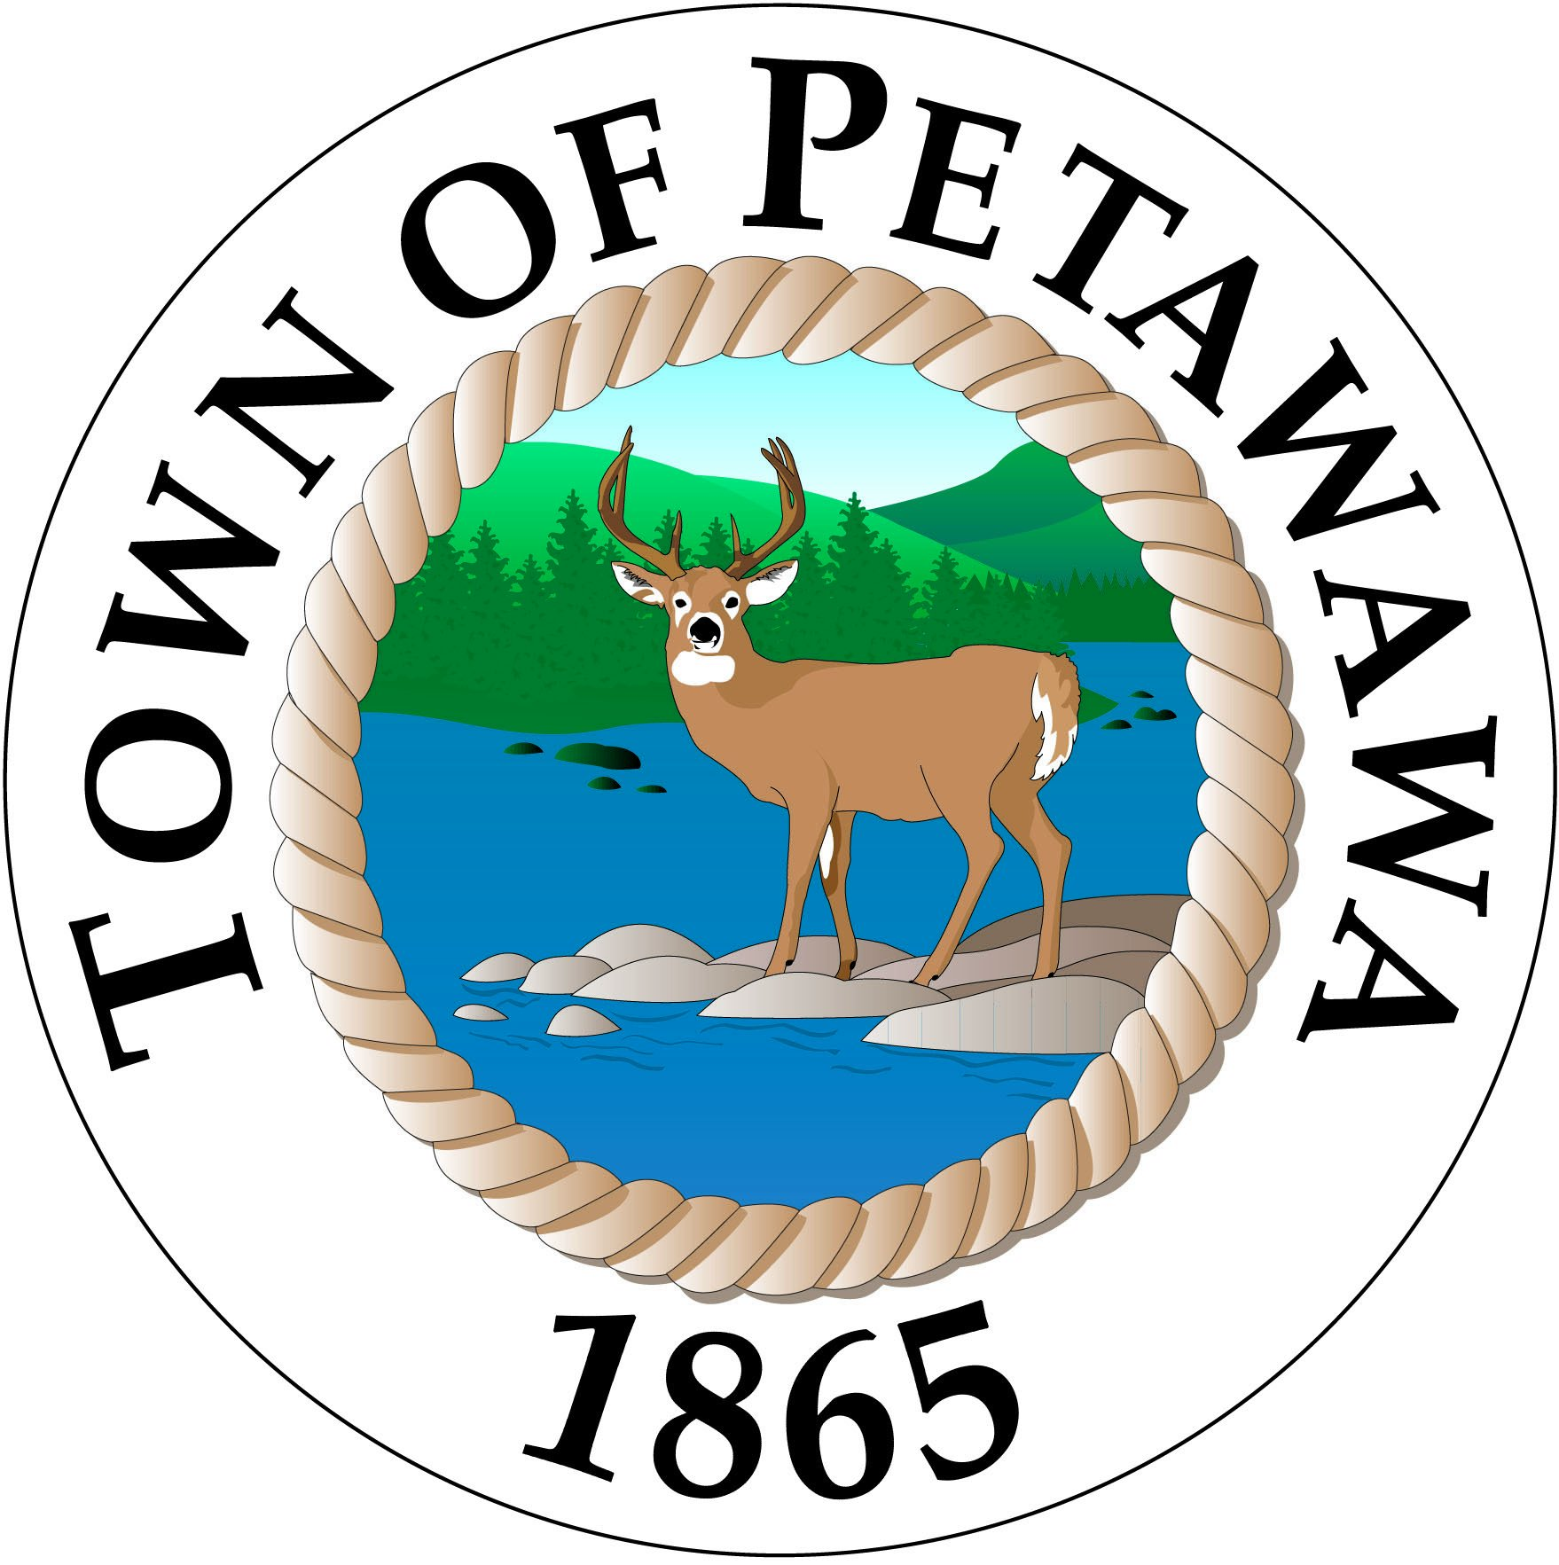

LIST OF CERTIFIED CANDIDATES

Notice is hereby given to the Municipal Electors of

Town of Petawawa, Town of Deep River, Town of Laurentian Hills, and the Township of Head, Clara and Maria

That during the period commencing on May 1, 2022 and completed on Nomination Day, August 19, 2022, the following persons filed all necessary papers, declarations and fees and as Deputy Clerk, I am satisfied that such persons are qualified and that their Nominations satisfy the requirements of the Municipal Elections Act, 1996. I have, therefore, certified such candidates for the office, which follows their respective name:

NAME OF CANDIDATE | OFFICE
David HOWARD | Trustee, Renfrew County Catholic District School Board
Myles VOSYLIUS | Trustee, Renfrew County Catholic District School Board

Given under my hand at 10:30 a.m. this 22nd day of August, 2022.

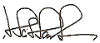

____________________________________
Daniel Scissons, Assistant Returning Officer
Deputy Clerk

