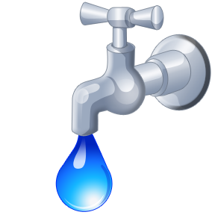

HOLIDAY WATER SAMPLES

The final drop-off before Christmas
will be December 21. Water samples
will not be accepted on the following days: December 22, 2021 through
to January 3, 2022.

