UOVSFC News for the week of Monday, May 4 2026
I told my physical therapist I broke my arm in two places.
He told me to stop going to those places.
The Chicken Pottery Workshops were enjoyed by all. Thank you to the Deep River Pottery Guild for their time and instruction; such a fun group to work with.

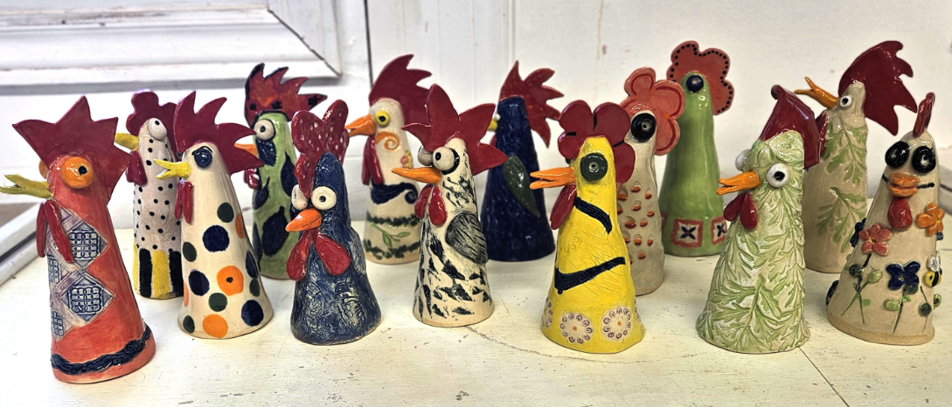
Roast Beef Dinner & DJ Dance Saturday, May 2, 2026. What a time we had! Great food, music, and best of all, great company! Thank you to everyone who helped, in any way; many hands ......
Tuesday, May 5 at 10 am - Guided Functional Breathing:
Join us at the Deep River Library in the Program Room. This 1 hour guided session offers experiential practices and techniques that aim to enhance your overall well-being, with practical applications that you can implement in your daily activities to strengthen independence and reduce stress. You will learn tools that help slow your breath, support jaw and tongue positioning, and guided breath sequences that help restore functional rhythm to the respiratory and pelvic diaphragms. Experience the many benefits of functional diaphragmatic breathing with practices that help expand lung capacity and improve breath control; boost immunity and aid digestion; strengthen heart rate variability and stamina; encourage circulation and pelvic floor health; and promote vitality, deep relaxation and sleep quality. Welcoming and inviting. No experience necessary. Practiced from seated on a chair. All are welcome, there is no cost to attend. **Please pre-register by contacting: 23uovsfc55@gmail.com
Wednesday, May 6 Walk in the Woods - there will be no walk this week. Fingers crossed for next week!
Thursday, May 7 at 10am - Coffee and Conversation will be at the Deep River Library program room.
Tuesday, May 12 at 9 am Framed Stained-Glass Picture Workshop. Join us in the Deep River Library Program Room for a stained-glass workshop led by Patricia Juby. There is space for 12 people. $40 per person to cover cost of supplies; there is a choice of three patterns (see photo of designs below). **Please pay by etransfer to 23uovsfc55@gmail.com or by cash or cheque in the drop box in the Deep River Town Hall before May 5th. Please provide your choice of pattern (flowers, dragonfly, or bee) when registering. If we do not receive more interest, we will need to cancel this workshop.
Tuesdays, May 19 and 26 at 9am - Ballroom Dancing with Mac and Elizabeth: Good news!! Mac and Elizabeth have generously offered to bring us more ballroom dancing on May 19 and 26 at 9 am at the DR Library program room. **Please register with 23uovsfc55@gmail.com if you wish to join in the fun. No cost. **If we do not receive more interest, we will need to cancel the lessons.
Saturday, May 23 - Community Kitchens Free Breakfast at the CEC - Our next free breakfast is on May 23, so mark it on your calendar and we hope to see you there. Poster below. If you wish to volunteer, please contact: sfcvolunteer54@gmail.com.
Also, on May 23 - Sing-along Saturday at 7 pm at the Deep River Legion. $5 at the door. Preregistration is encouraged so we know how many guests to expect; please email: 23uovsfc55@gmail.com. See poster below.
Tuesday, June 2 at the Deep River Legion at 9am – Join us as Anne Mykolyshyn instructs us on how to make beautiful Pysanky Eggs. Nonrefundable cost per person is: $35. Deadline to pay/register is May 19. Payment may be made to: 23uovsfc55@gmail.com or by dropping your payment with a note into the SFC dropbox on the counter at the Deep River town hall.
Tuesday, June 9 - 2 Speakers at the Deep River Library program room.
First at 9am, Nina Shah, pharmacist with Deep River’s Pharmacy, will discuss how skin changes with age, common skin conditions, how to care for our skin, and much more.
Next at 11am, Makyla Gendron speaking about the Community Connector Program – helping older adults connect to local services. There is no cost to attend these talks; all are welcome to attend.
Thursday, June 11, Noon - 2pm AGM and BBQ at the Deep River Legion. Please join us for our annual General Meeting and BBQ. BBQ will consist of hot dogs and hamburgers, fruit and veggies trays, dessert, tea/coffee at a cost of $5 per person, nonrefundable.
If you wish to join us for the AGM/BBQ please register no later than June 1st, with etransfer and stating your preference (hotdog or hamburger) to: 23uovsfc55@gmail.com; payment may also be made at the SFC drop box at the Deep River town hall. Reports will be emailed to members in advance of the meeting.
At the AGM we will be asking for nominations for the Vice President role. Our current VP’s term is coming to an end; if you wish to find out more about this role, please contact the UOVSFC President, Wanda Harvey, at: wanda.harveylg@gmail.com.
Valvular heart diseases are dysfunctions of the doors that direct blood flow within the heart. These diseases affect hundreds of thousands of people in Canada. Heart valve problems are often undetected, and late detection may have severe consequences. A free screening conducted by the Ottawa Heart Institute is being hosted by the UOV Senior’s Friendship Club for people 65+ with no known heart issues.
The mobile screening program offers early detection, diagnosis and treatment. Registration for the Valvular Heart Disease Screening Clinics on April 30th, October 20th and November 5th is now closed. If you have registered and have any questions about your appointment, please call 613-696-7412 or email at: heartvalve@ottawaheart.ca.
The Upper Ottawa Valley Seniors Friendship Club is open to all adults living in the area from Chalk River to Deux Rivieres. Website https://seniorsfriendshipclub.ca
Facebook https://www.facebook.com/sfc.uov
Melanie Theil, for Ann Serdula, with information and proof reading from others.
TUESDAY, May 12, 2026

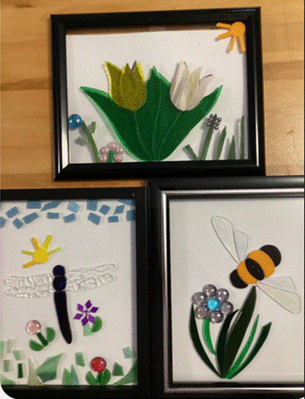
SATURDAY, MAY 23, 2026
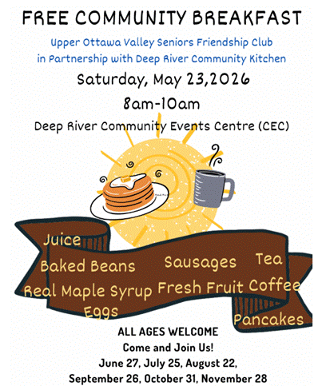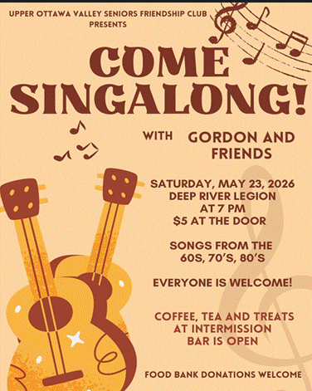

Take good care.
Mel

Melanie Theil on behalf of the Seniors Friendship Club
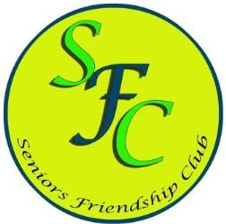

Webpage: https://seniorsfriendshipclub.ca/ FB page: Sfc Uov

